Assignment – 2
Facial recognition using OpenCV and deep learning
for binary classification

Problem Statement:
The objective of this assignment is to implement facial recognition using OpenCV and deep learning techniques to perform binary classification. Specifically, the system will classify whether a given image contains a specific person (positive class) or not (negative class). This type of classification is commonly used in security systems, user authentication, and access control.

Software used:
- Python 3.x
- Google Colab

Libraries and packages used:
- opencv-python: For detecting faces in images.
- tensorflow / keras: For training and applying the deep learning model.
- numpy: For handling array operations.
- os: For reading and managing image datasets.
- scikit-learn: For splitting data and evaluating model performance.

Theory:
Facial recognition is the process of identifying or verifying a person by analyzing their facial features. It involves two main steps:
- Face Detection: Locating faces in an image.
- Face Recognition: Identifying or verifying the detected faces.
For binary classification, the task is to distinguish between two classes:
- Positive Class: Images of a specific individual.
- Negative Class: Images of other individuals or backgrounds without the specific individual.
Components:
- OpenCV is used for face detection, leveraging techniques like Haar Cascades or Deep Neural Networks (DNN).
- Deep Learning (Convolutional Neural Networks - CNNs) is used to train a model that learns to differentiate between two classes based on the facial features extracted.

Methodology:
- Data Collection: Collect a dataset of face images containing positive examples (images of the target person) and negative examples (images without the target person).
- Preprocessing:
- Use OpenCV to detect faces in images.
- Resize and normalize face images for training.
- Model Architecture:
- Build a Convolutional Neural Network (CNN) using Keras.
- The CNN will consist of several convolutional, pooling, and dense layers.
- Binary Classification:
- Train the model using the labelled face data.
- Classify the input images into two categories: target person or not.
- Model Evaluation: Evaluate the trained model using accuracy, precision, recall, and F1-score.

Advantages:
- High Accuracy: Deep learning models like CNNs can achieve high accuracy in facial recognition tasks.
- Automatic Feature Extraction: CNNs automatically extract and learn important features from the input images.
- Scalable: The system can easily be extended to handle multiple people (multi-class classification).

Limitations:
- Large Dataset Requirement: Deep learning models often require a large dataset to perform well.
- Computationally Expensive: Training deep models can be time-consuming and resource-intensive.
- Privacy Concerns: Use of facial recognition can raise ethical and privacy issues.

Applications with example:
- Security Systems: Identifying authorized personnel in secured areas.
- User Authentication: Unlocking devices using face recognition (e.g., smartphone authentication).
- Surveillance Systems: Monitoring and identifying individuals in public places for security purposes.
Example: In a building with restricted access, the system can be used to verify whether a person is authorized to enter by comparing their face with a pre-registered face.

Working / Algorithm:
- Load and Preprocess Data:
- Collect and load positive and negative image data.
- Detect faces in images using OpenCV.
- Resize and normalize the images for model input.
- Model Design: Build a CNN model using Keras for binary classification.
- Training:
- Split the dataset into training and test sets.
- Train the CNN model on the training data.
- Testing and Evaluation: Evaluate the trained model on test data using metrics like accuracy and F1-score.

Diagram:
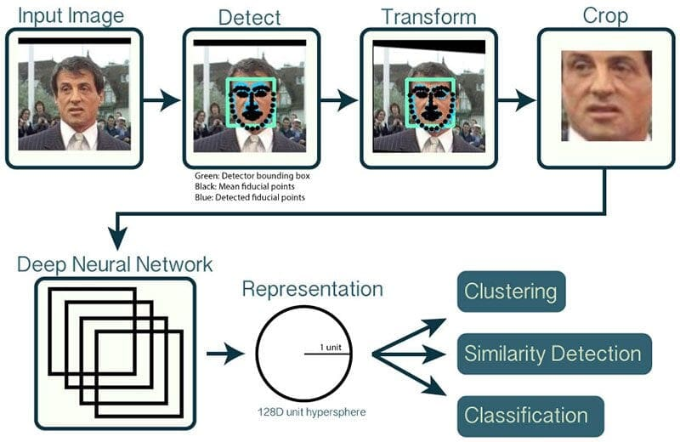

Conclusion:
The implementation of a facial recognition system using OpenCV and deep learning for binary classification provides a robust solution for identifying or verifying individuals. By combining face detection using OpenCV with the power of Convolutional Neural Networks for feature learning and classification, we can achieve high accuracy in distinguishing between specific individuals and others. This system is highly adaptable and can be extended to multi-class problems for recognizing multiple people or applied to other biometric systems.

